1. 1 International-Core-WinPE | InputLocale = es-ES SystemLocale = es-ES UILanguage = es-ES UserLocale = es-ES 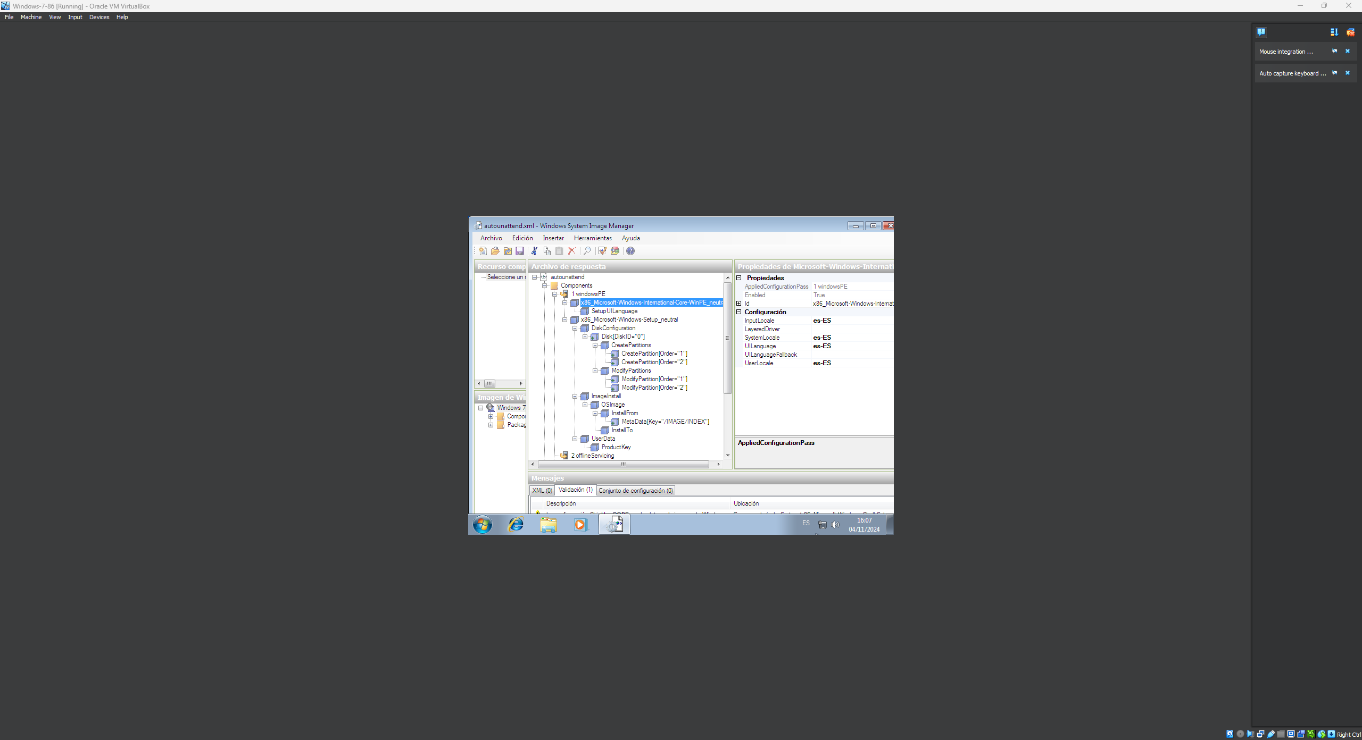
2. 1 International-Core-WinPE\SetupUILanguage | UILanguage = es-ES WillShowUI = OnError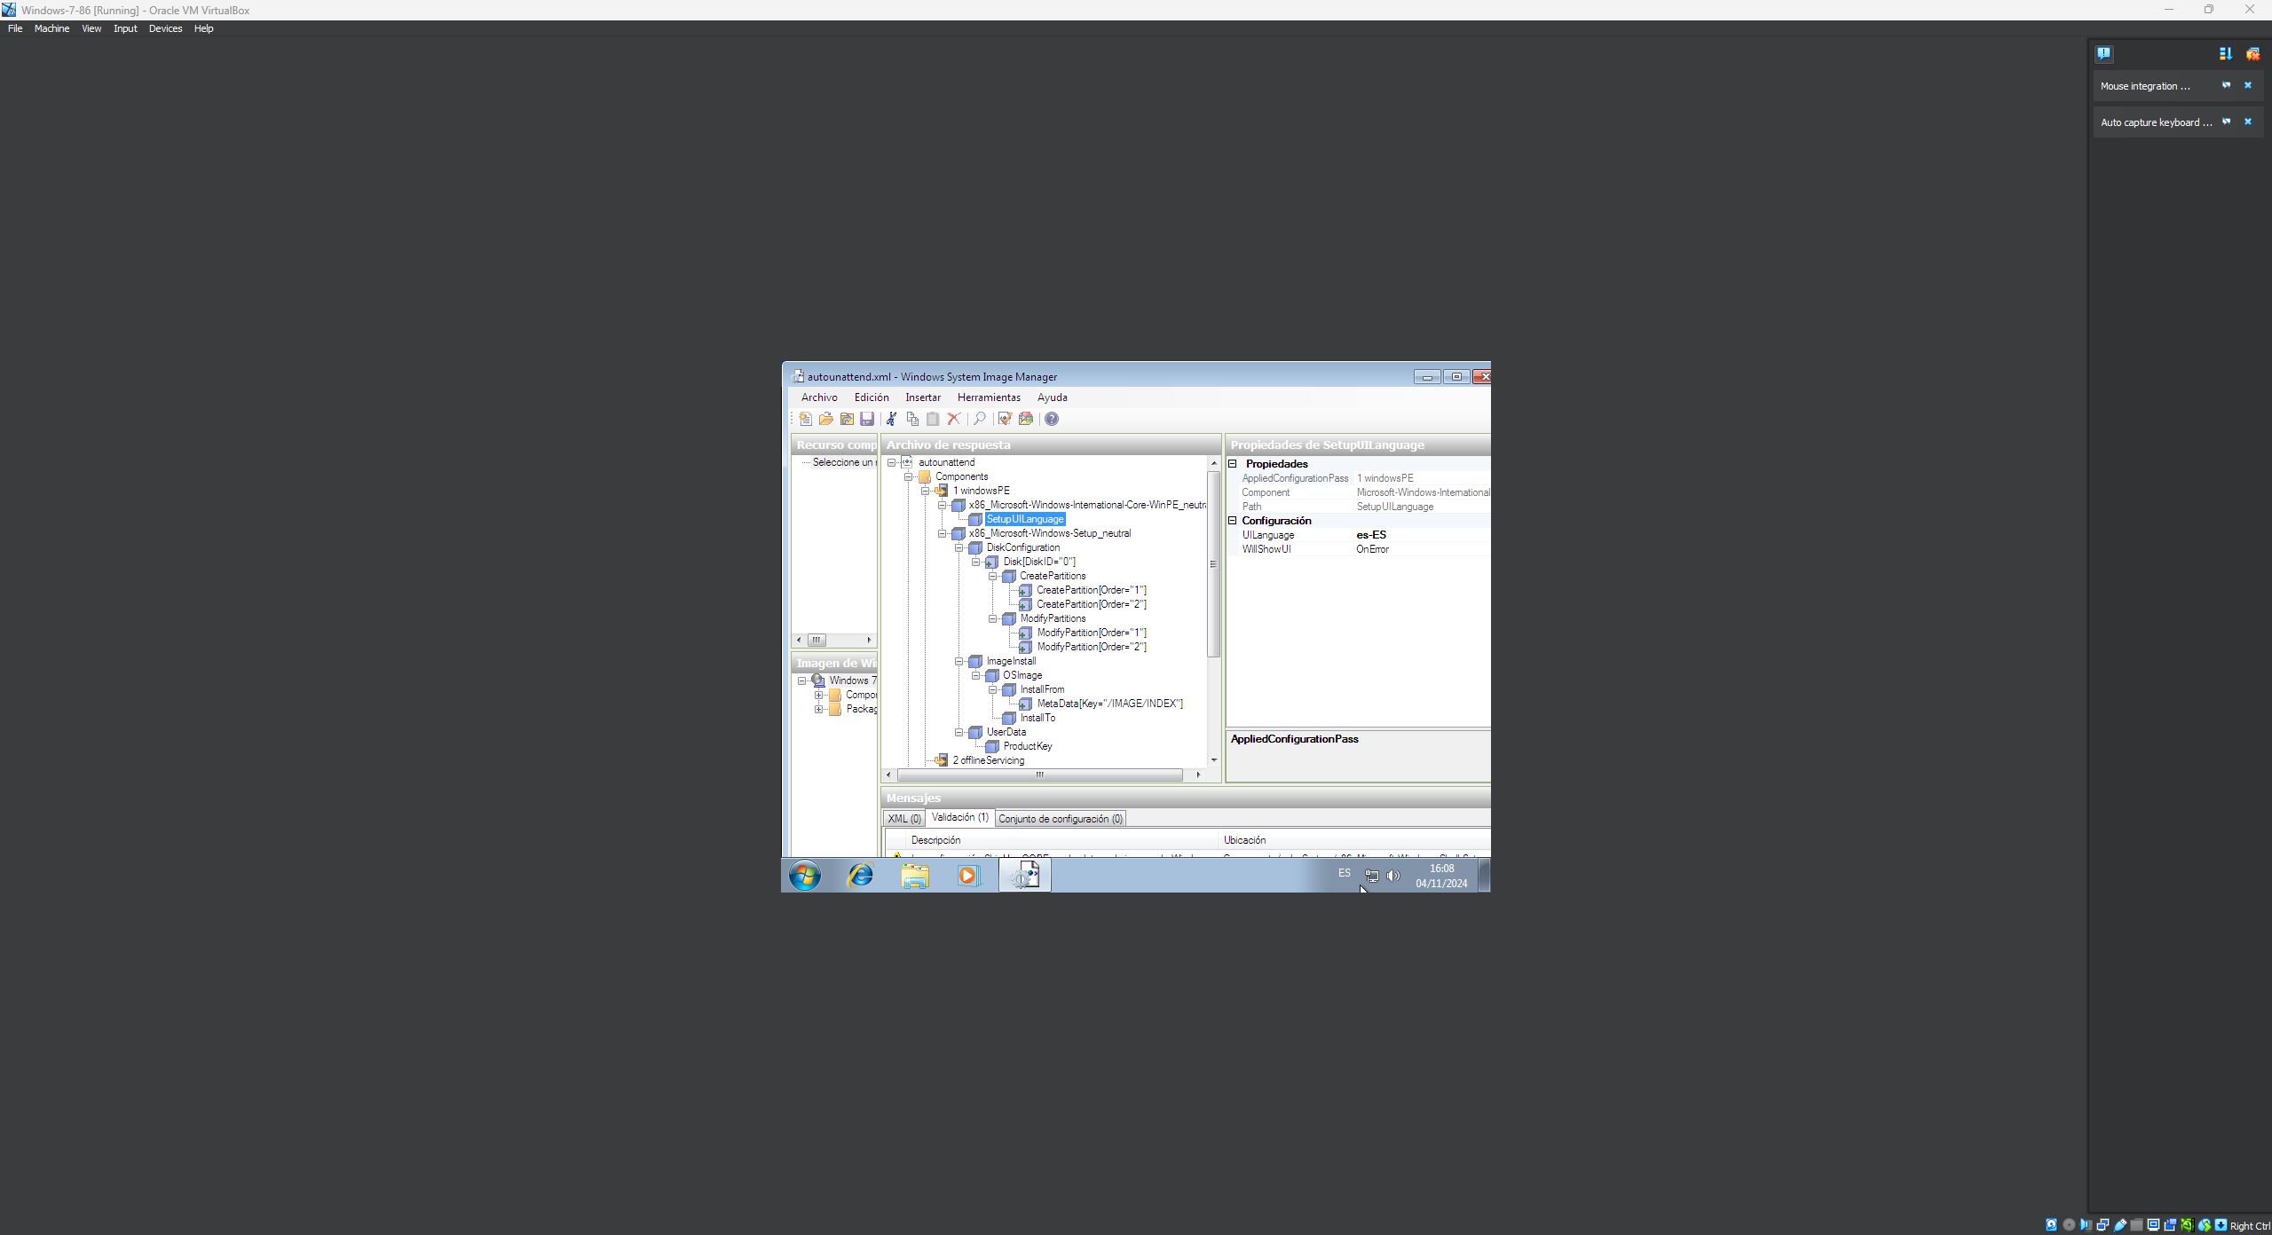
3. 1 Setup\DiskConfiguration | WillShowUI = OnError 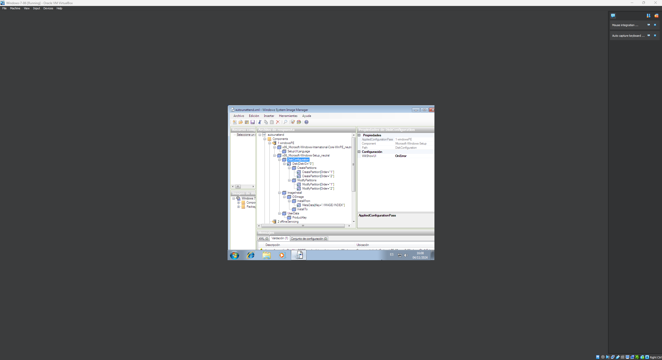
4. 1 Setup\DiskConfiguration\Disk | DiskID = 0 WillWipeDisk = true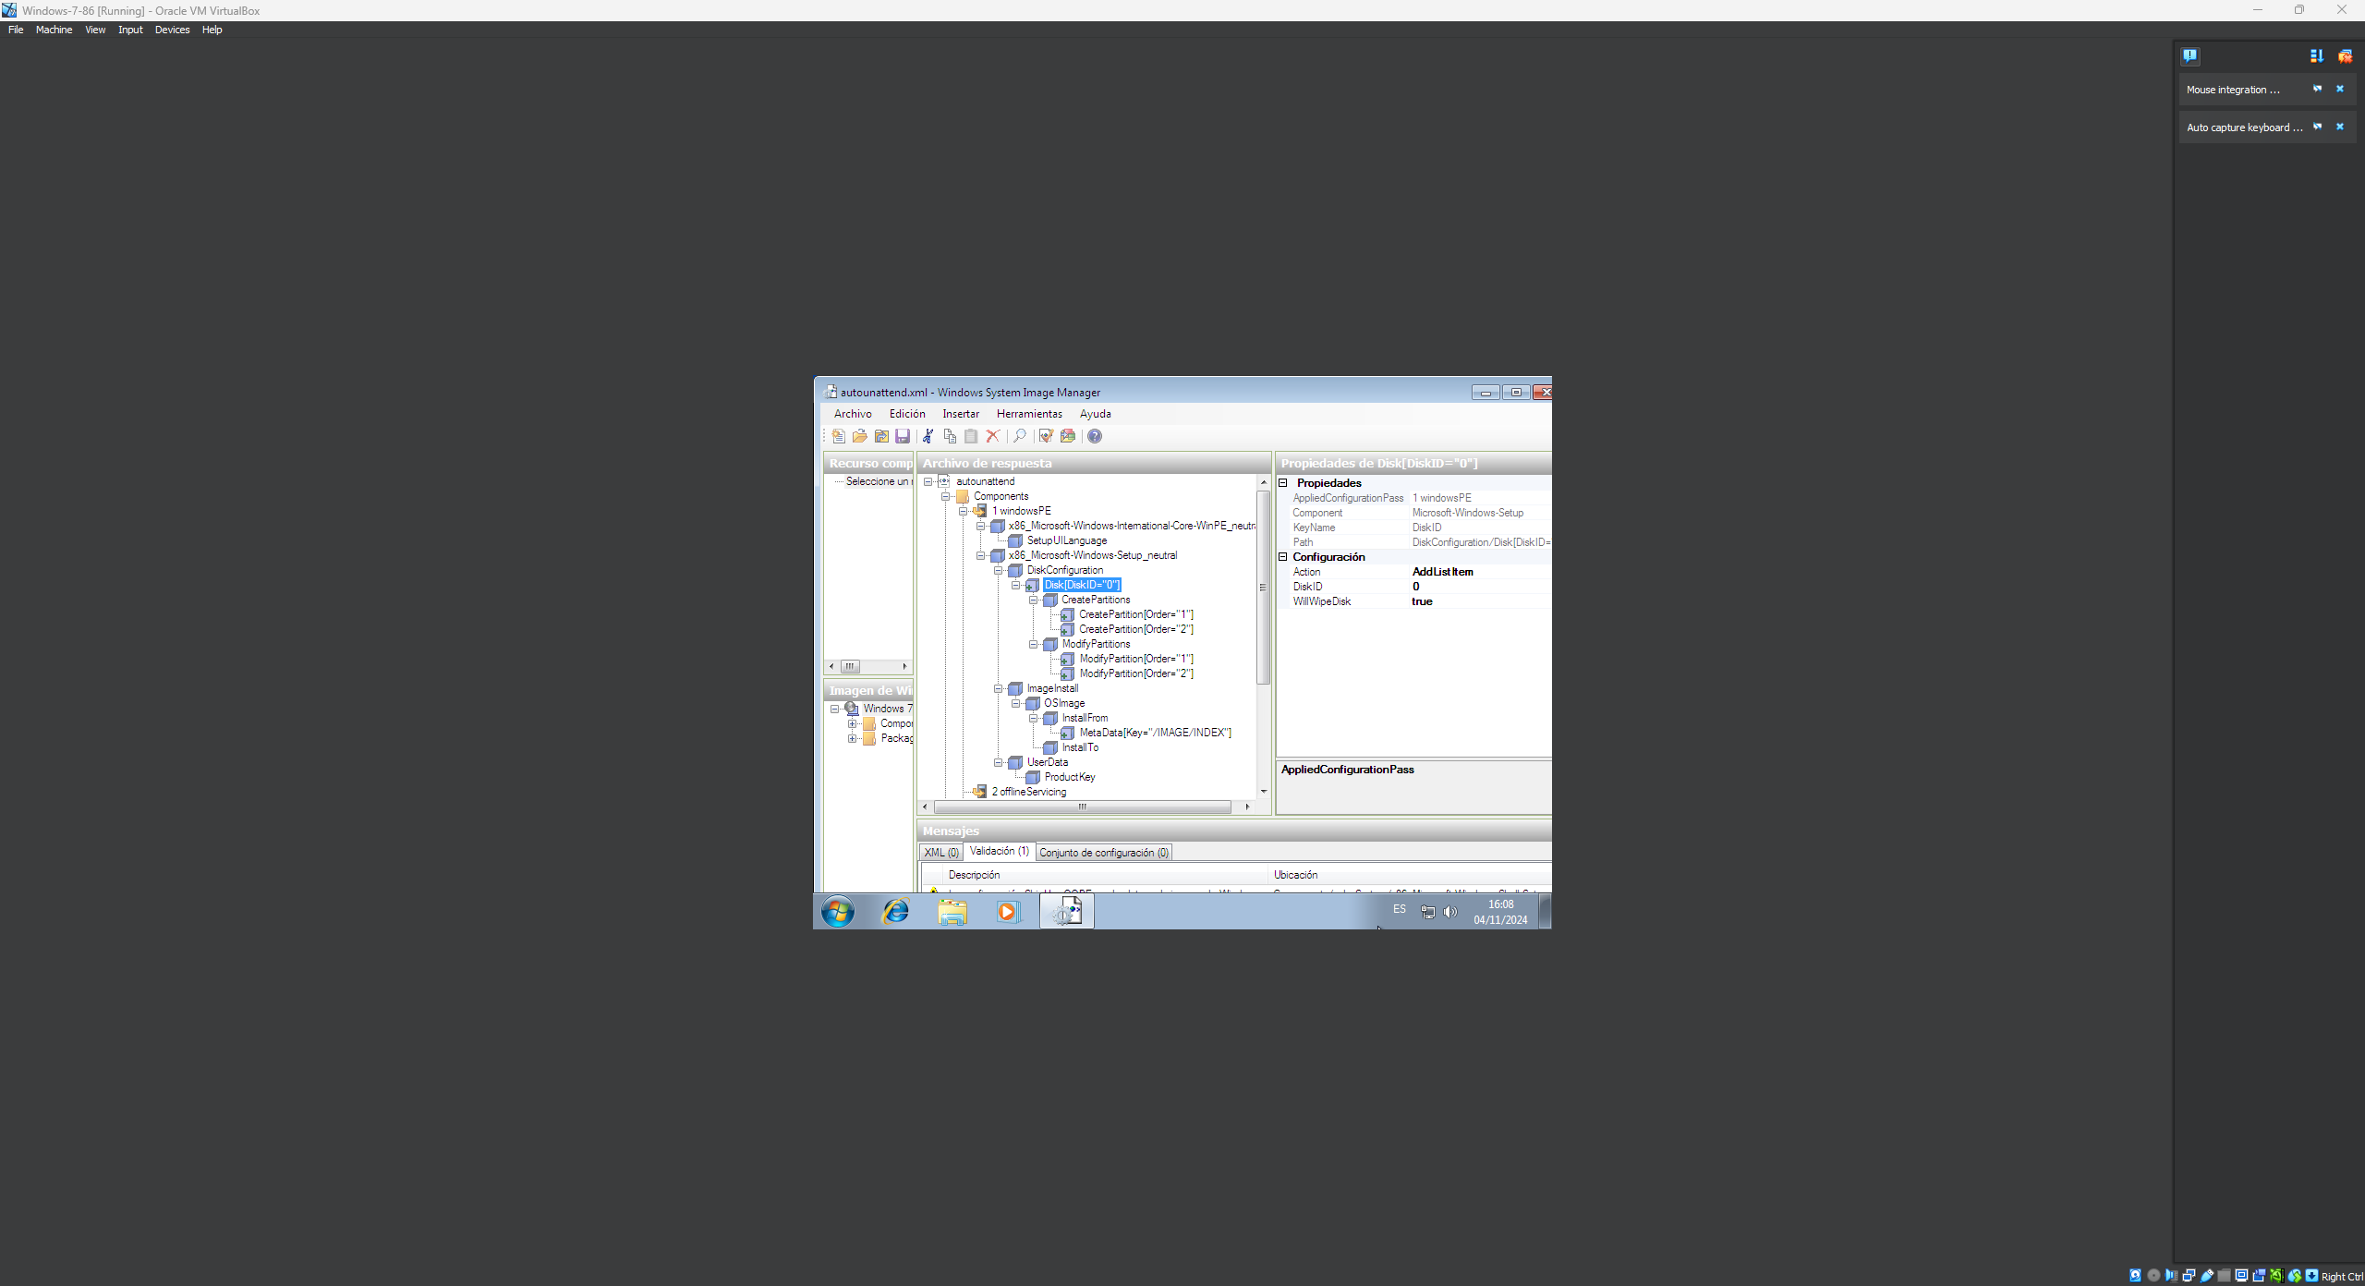
5. 1 Setup\DiskConfiguration\Disk\CreatePartitions\CreatePartition | Order = 1 Size = 200 Type = Primary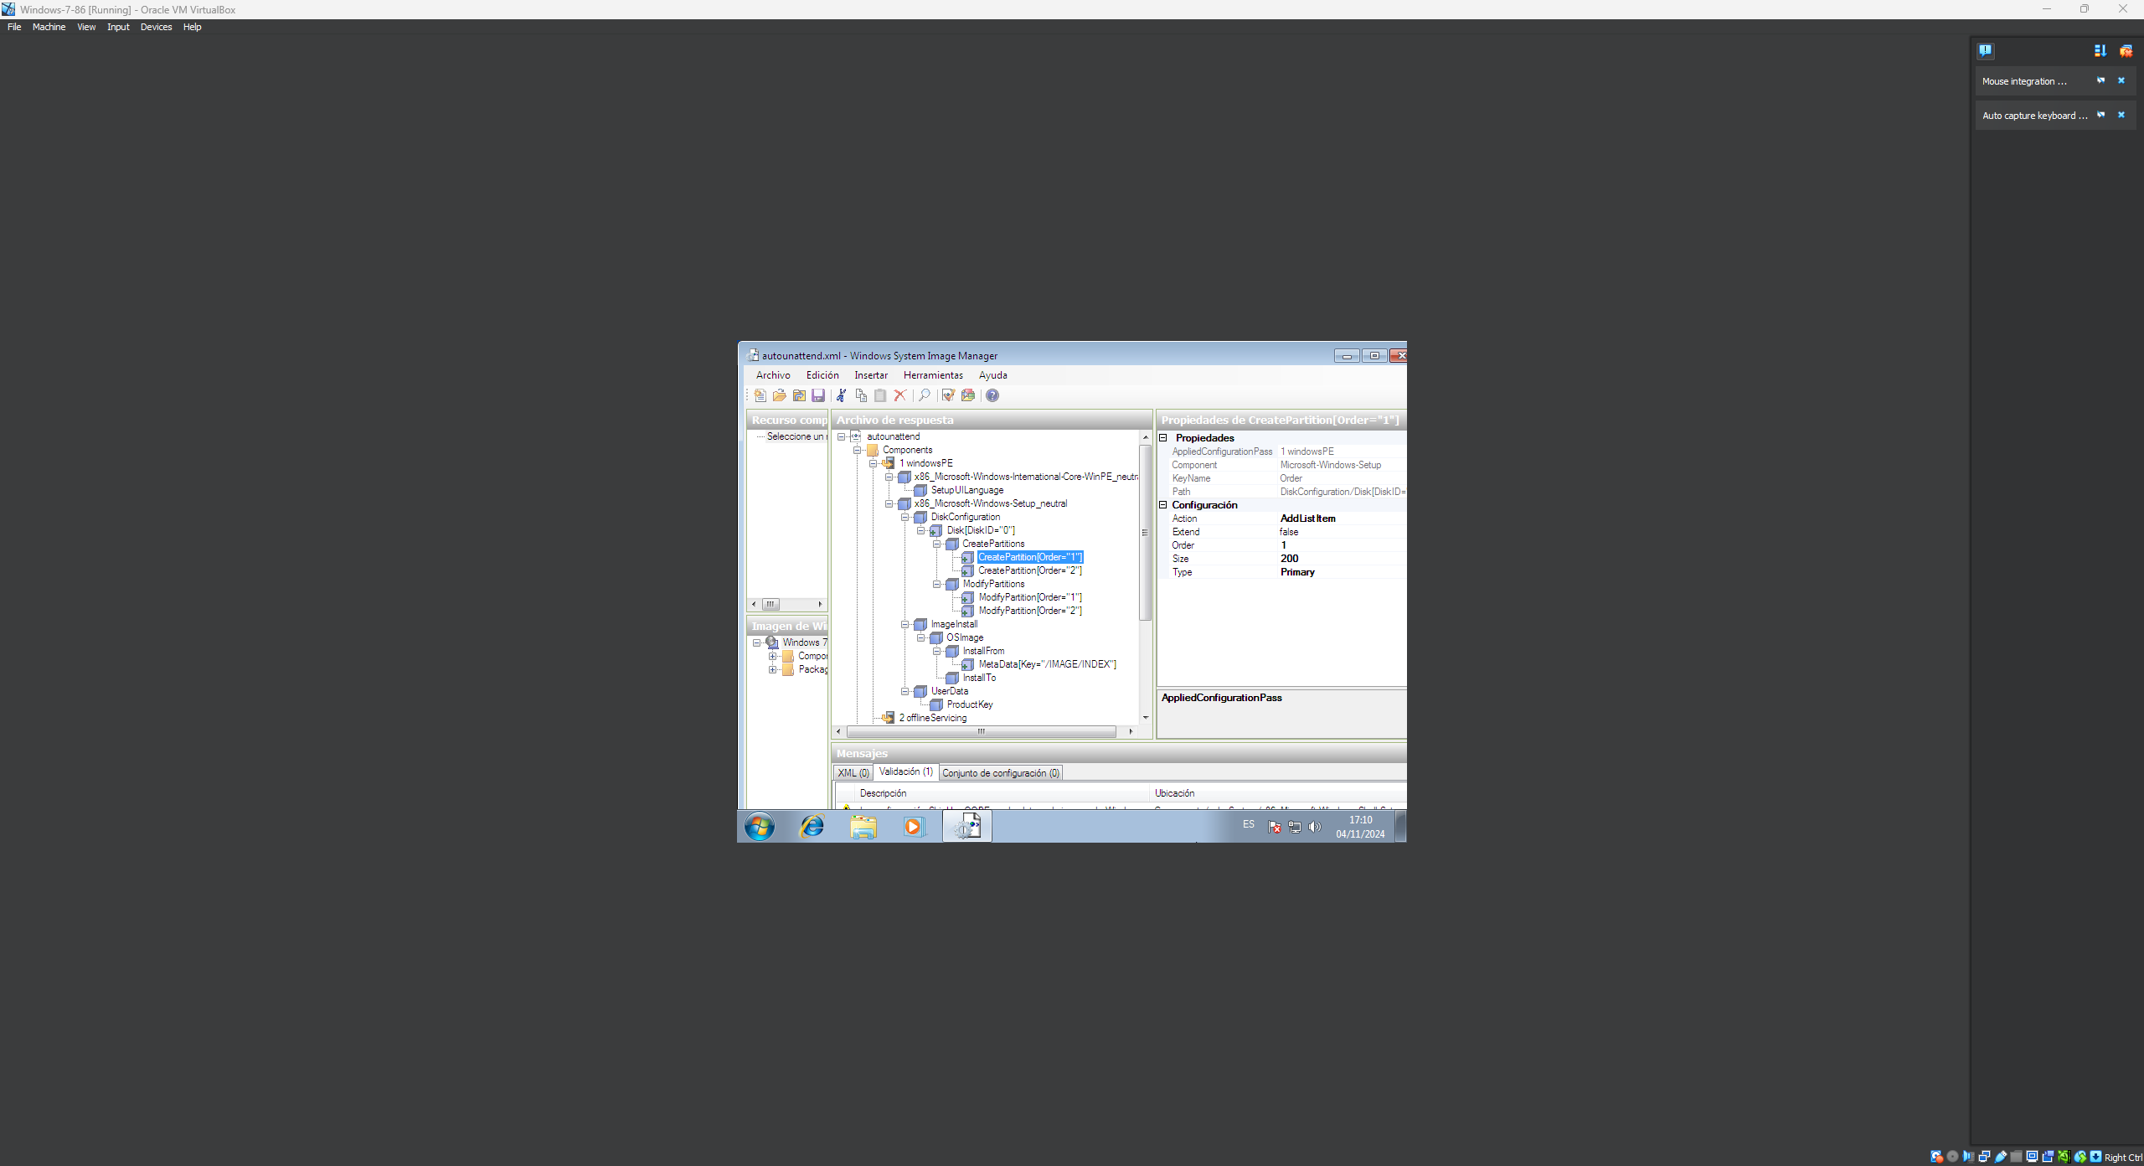
6. 1 Setup\DiskConfiguration\Disk\CreatePartitions\CreatePartition | Extend = true Order = 2 Type = Primary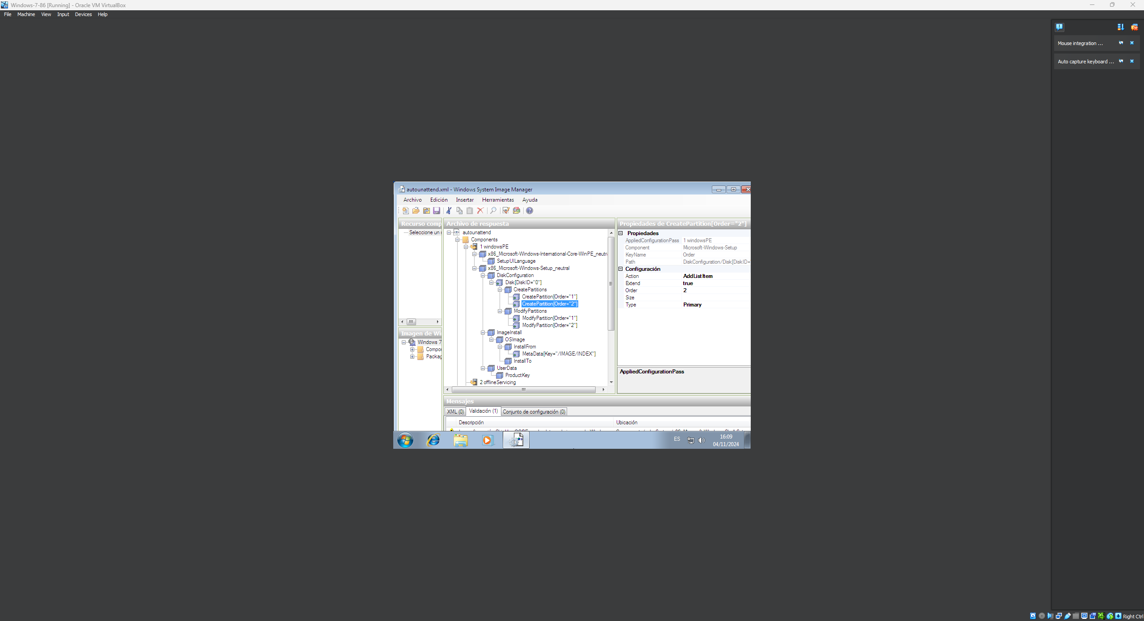
7. 1 Setup\DiskConfiguration\Disk\ModifyPartitions\ModifyPartition | Active = true Format = NTFS Label = System Order = 1 PartitionID = 1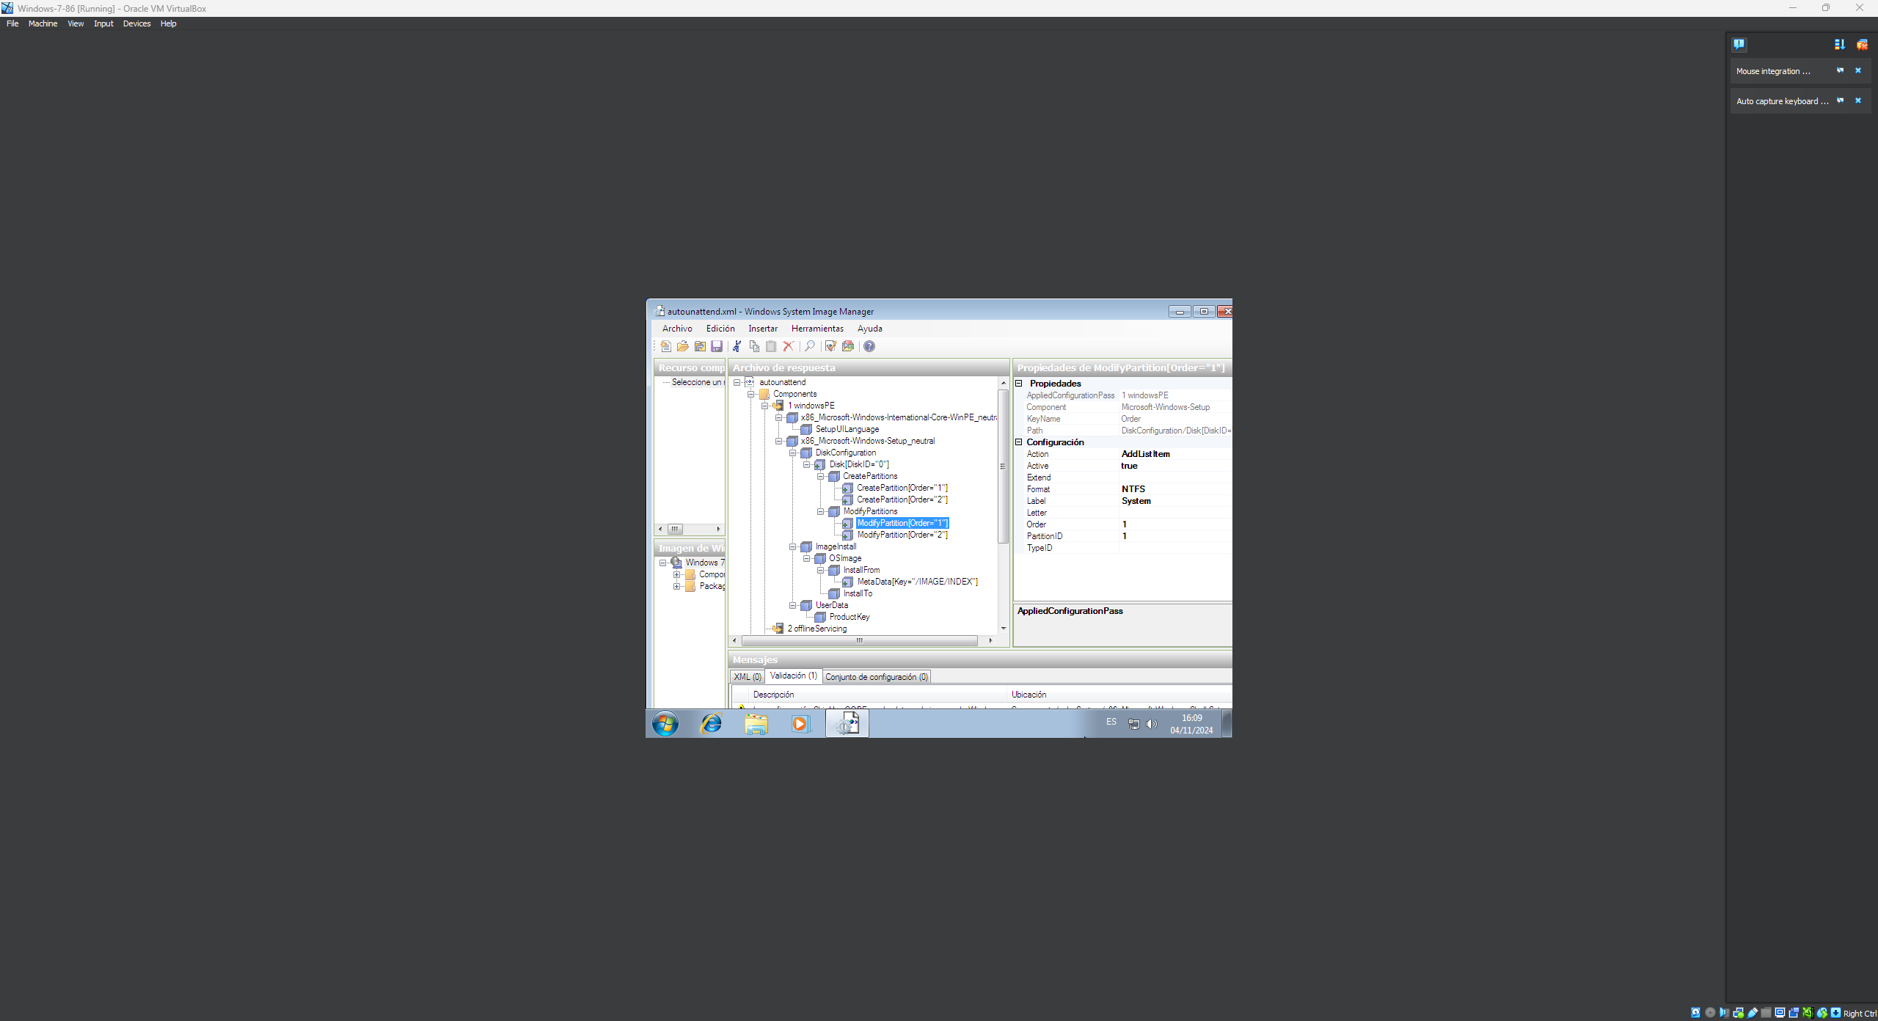
8. 1 Setup\DiskConfiguration\Disk\ModifyPartitions\ModifyPartition | Format = NTFS Label = Windows Order = 2 PartitionID = 2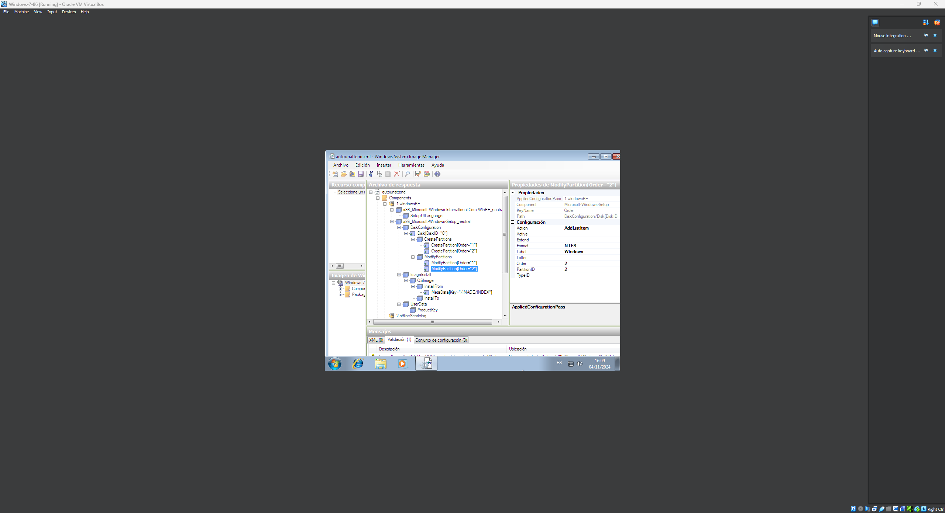
9. 1 Setup\ImageInstall\OSImage | InstallToAvailablePartition = false WillShowUI = OnError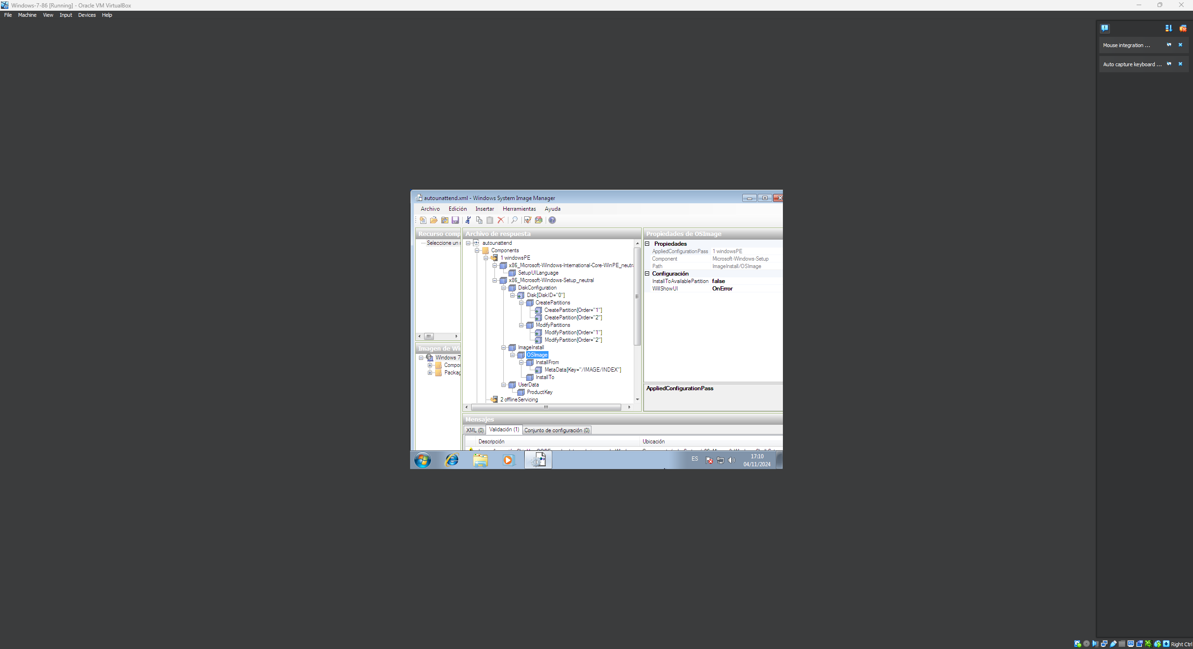
10. 1 Setup\ImageInstall\OSImage\InstallFrom\MetaData | Key = /IMAGE/INDEX Value = 7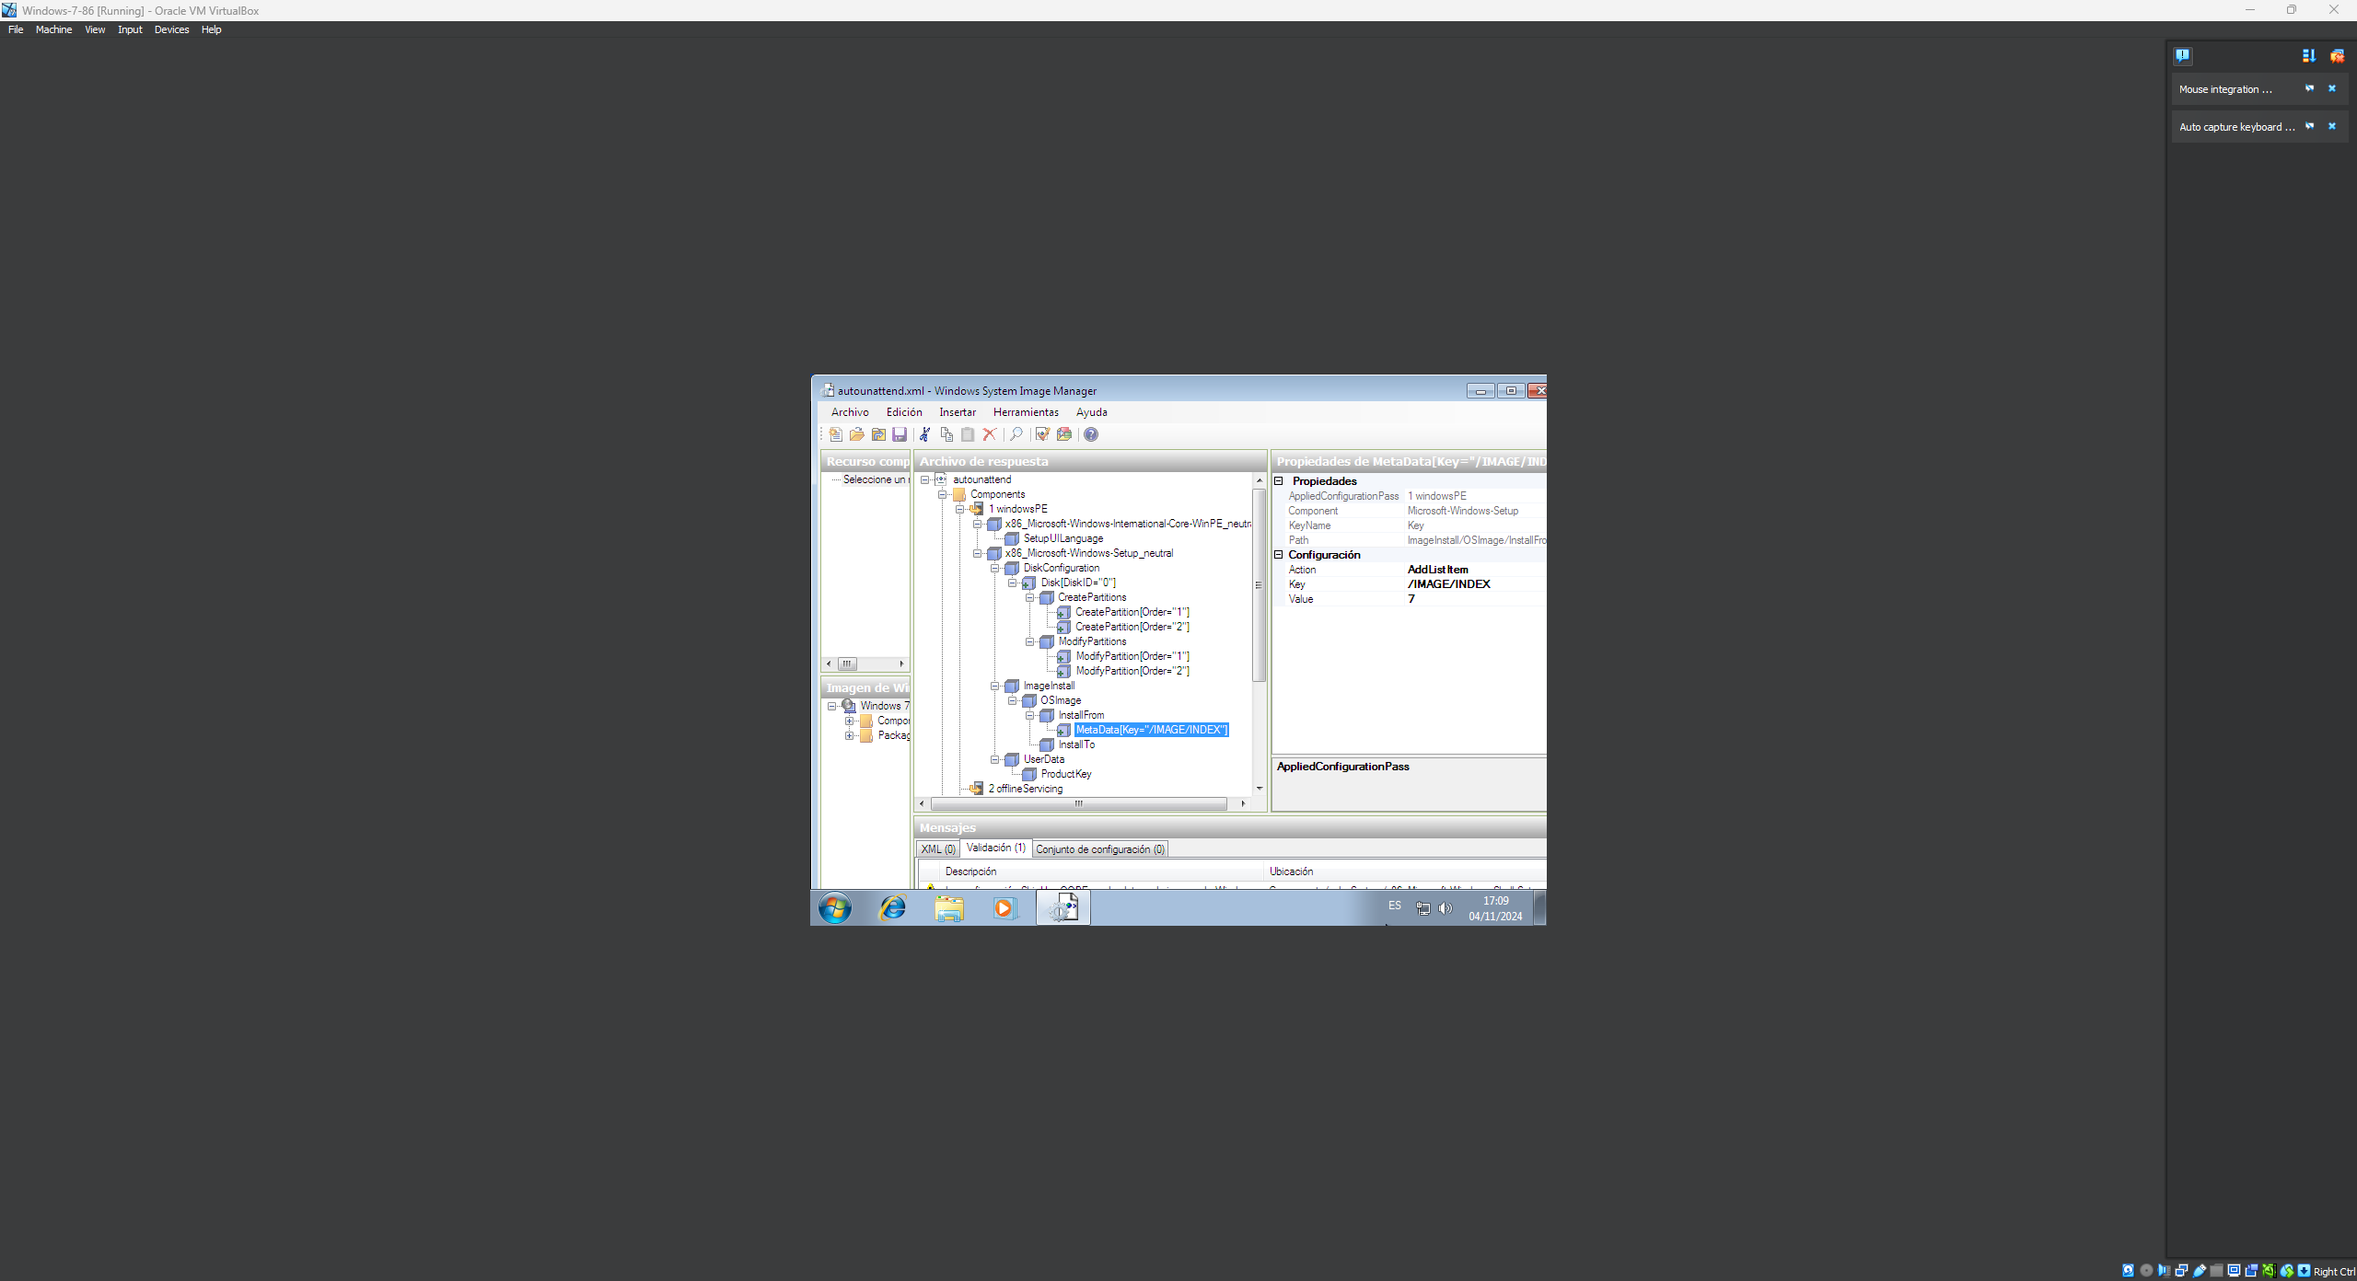
11. 1 Setup\ImageInstall\OSImage\InstallTo | DiskID = 0 PartitionID = 2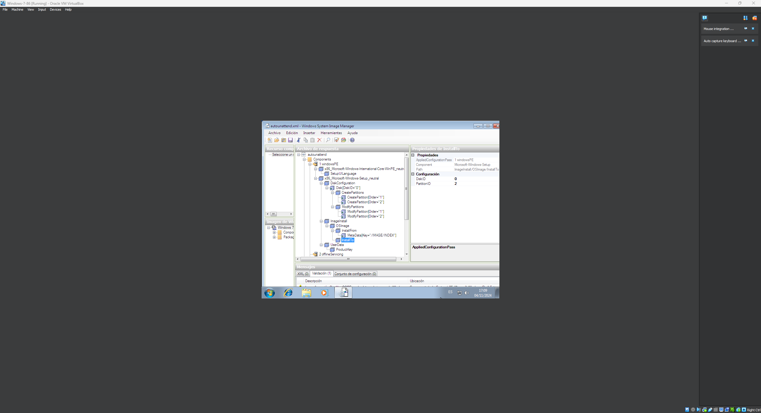
12. 1 Setup\UserData | AcceptEula = true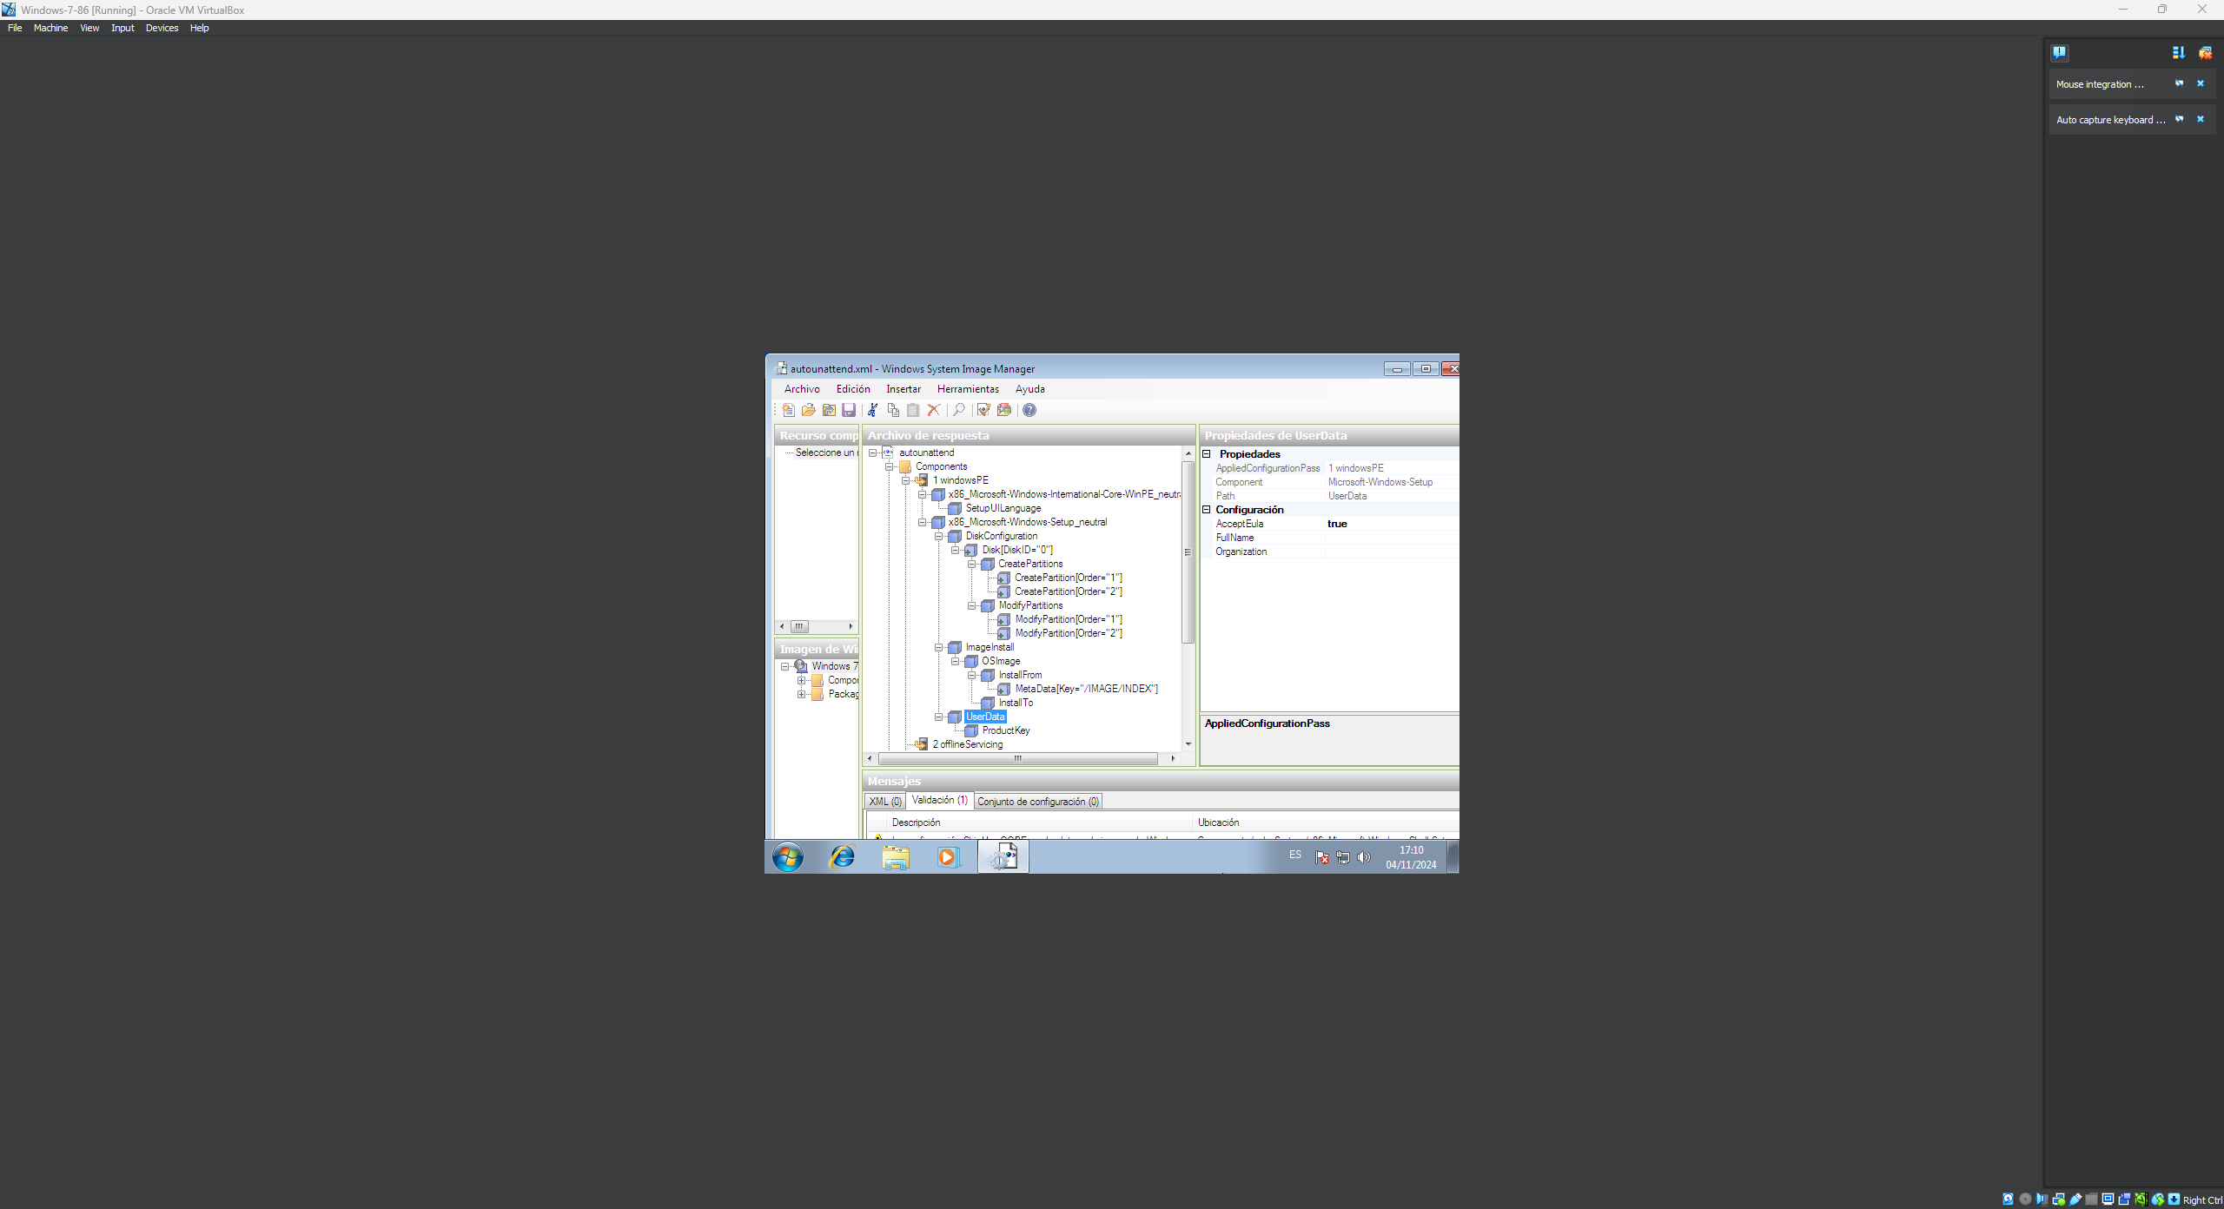
13. 1 Setup\UserData\ProductKey | Key = HYF8J-CVRMY-CM74G-RPHKF-PW487 WillShowUI = OnError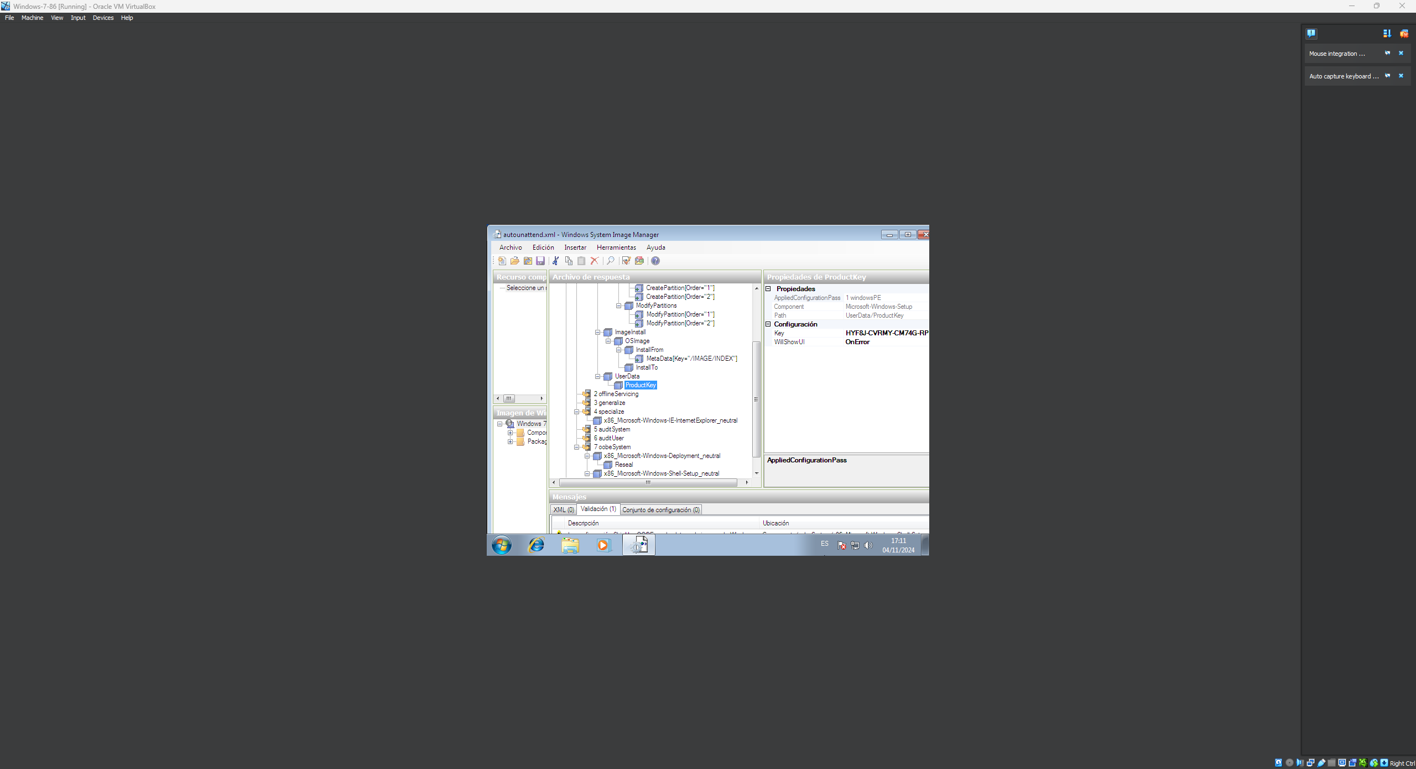
14. 4 IE-InternetExplorer | Home_Page = www.google.com 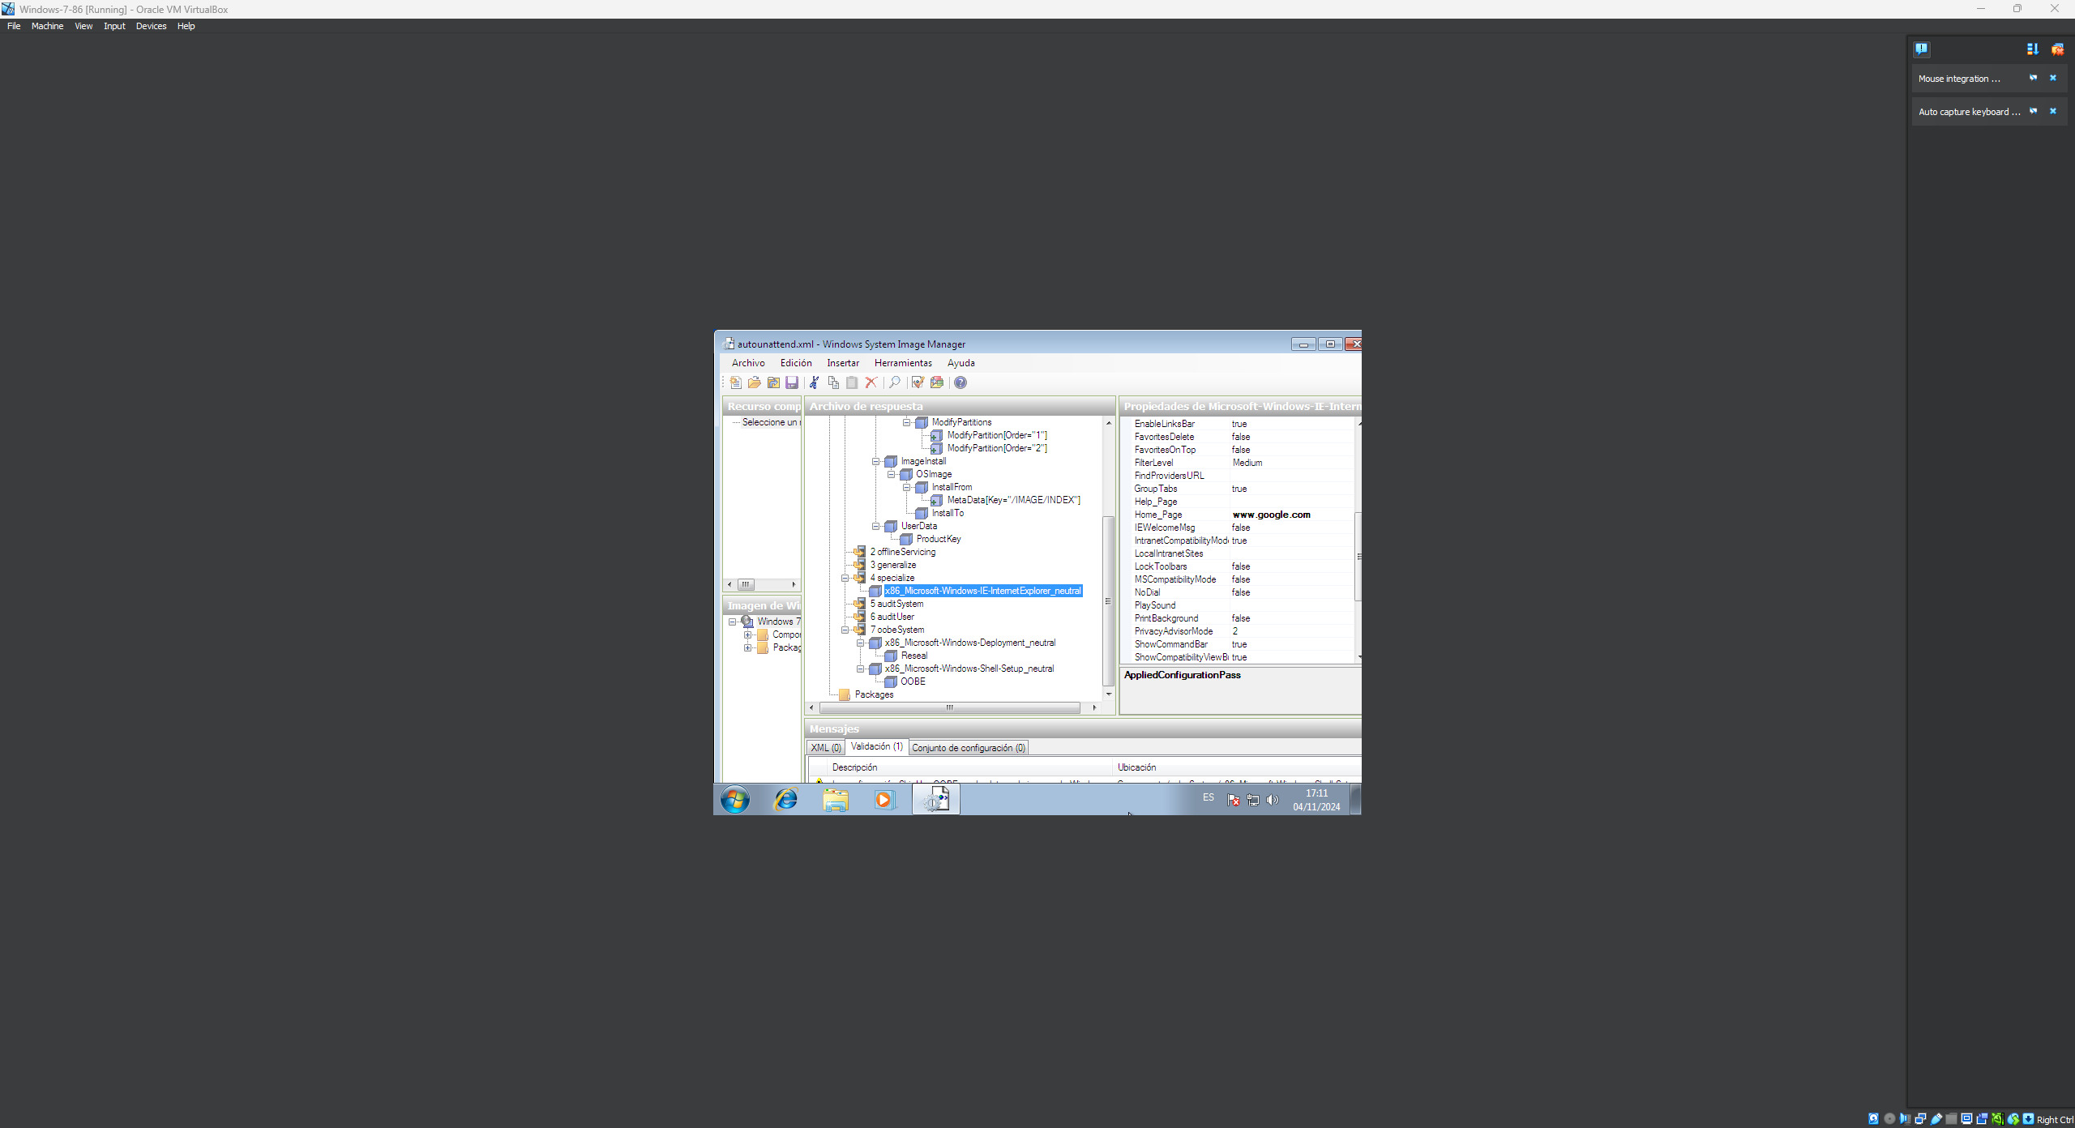
15. 7 Deployment\Reseal | ForceShutdownNow = false Mode = Audit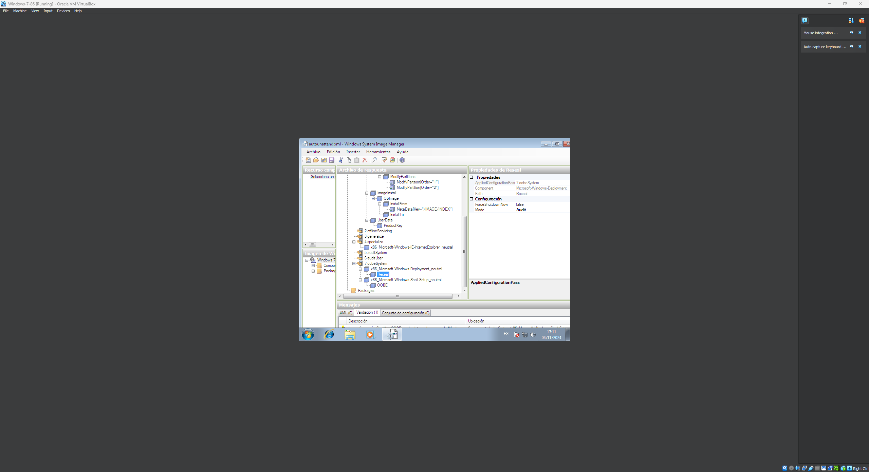
16. 7 Shell-Setup\OOBE | HideEULAPage = true ProtectYourPC = 3 SkipUserOOBE = true